8) 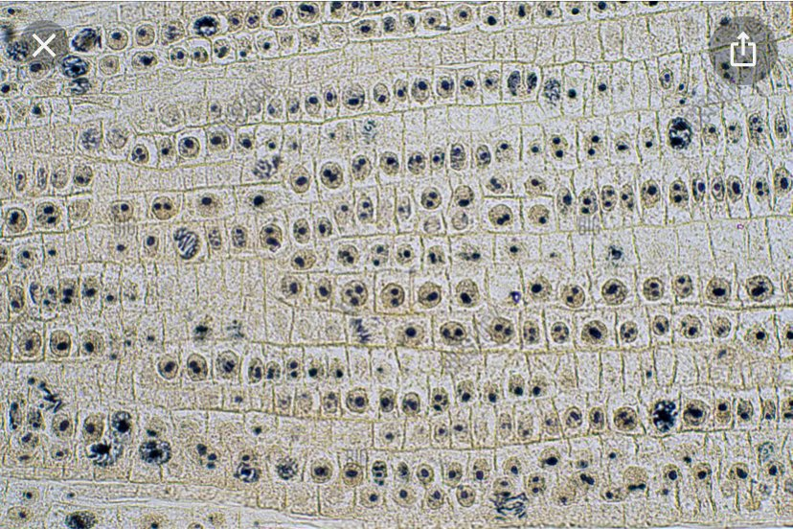
9) Count the number of cells containing the different phases of mitosis from the table above. The table above contains different stages of cell growth namely: interphase, prophase, metaphase, telophase and anaphase.
Interphase 18
Prophase 12
Metaphase 6
Telophase 2
Anaphase 2
10) From the values of the phases above, divide them by the total number of cells counted which was 40, then multiplied by 16.
Interphase 18/40 X 16 = 7.2 hours
Prophase 12/40 X 16= 4.8 Hours
Metaphase 6/40 X 16 = 2.4 hours
Telophase 2/40 X 16= 0.8 hours
Anaphase 2/40 X 16= 0.8 hours
11) Interphase with 7.2 hours

